# Dataflow Diagrams

Dataflow diagrams depict the flow of information and data in a system or for its individual processes. Constructing this diagram allows for a more user friendly interpretation of information and interaction. Various levels of dfd’s exist which can focus more specifically on a system as a whole or on individual processes.

**Context Level DFD**

A context level DFD is a top level diagram which contains only one process node and generally depicts the major outcomes of the system. Other levels of diagram can progress in order to reach a narrower scope of aspects and interactions. E.g. in our system a context level may be as simple as patient/clinician/database -> app and then more specific diagrams can be deduced from this basis.

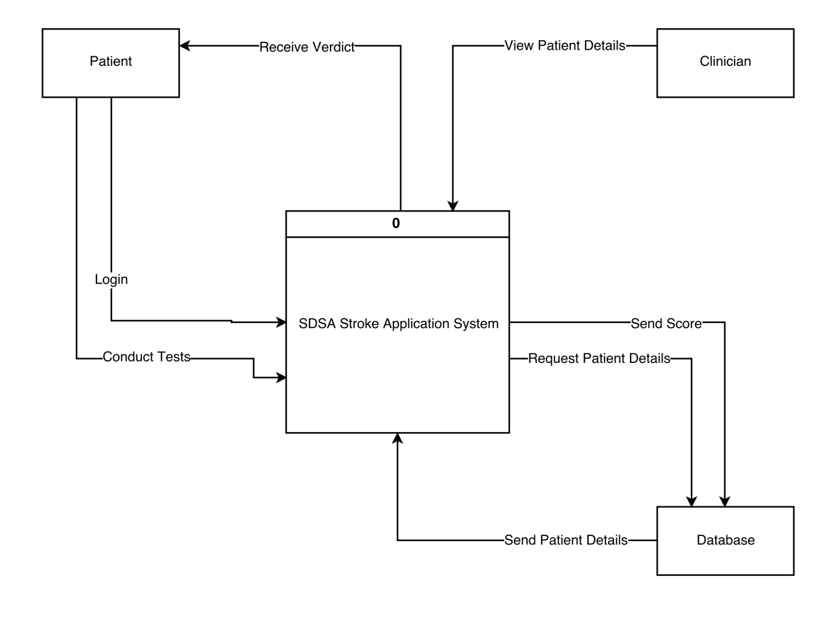

**Level One DFD**

After conducting dataflow analysis the group decided that only context and level 1 diagrams were required to accurately depict the system, further levelling could be conducted however was not deemed necessary. The level one DFD depicts the sub-systems and processes that operate in the system, external agents and the flows between them. Each process node must have at least one dataflow to an external agent which as shown our diagram does.

